**PROJECT REPORT**

**ON**

**HYDROSENSE**

# Water Management & Soil Moisture Level Detection



REPORT SUBMITTED

TO

VISHWAKARMA INSTITUTE OF INFORMATION TECHNOLOGY, PUNE

For the PBL of Environmental Science BS10233

IN

**DEPARTMENT OF ENGINEERING AND APPLIED SCIENCES**

**AY 2023-24**

**Semester II**

BY

|  |  |  |  |  |
| --- | --- | --- | --- | --- |
| **P. R. No.​**  **​** | **Roll No.​**  **​** | **Name of Student​**  **​** | **Mobile No.​**  **​** | **VIIT email ID​**  **​** |
| 22311251​ | 101145​ | Tanushri Chetan Rajput​ | 8446029351​ | tanushri.22311251@viit.ac.in​ |
| 22311496​ | 101149​ | Atharva Rajendra Joshi​ | 9527043551​ | atharva.22311496@viit.ac.in​ |
| 22311517​ | 101153​ | Revati Tushar Aute ​ | 8208092760​ | revati.22311517@viit.ac.in​ |
| 22311608​ | 101158 ​ | Manas Girish Kulkarni ​ | 7972470825​ | manas.22311608@viit.ac.in​ |
| 22311679 ​ | 101161​ | Atharva Vishwas Deshpande​ | 9309358960​ | atharva.22311679@viit.ac.in​ |

**Class: F. Y. B. Tech. Division: A Batch: A3**

**Batch Incharge**

**Mr. Vivek Shripad Nagnath**

**INDEX**

|  |  |  |
| --- | --- | --- |
| **Sr. No.** | **Contents** | **Page No.** |
| **1** | **ABSTRACT** | 1 |
| **2** | **OBJECTIVE / S** | 2 |
| **3** | **INTRODUCTION / THEORY** | 3 |
| **4** | **EXPERIMENTAL METHOD / S (USED / PROPOSED)** | 4 |
| **5** | **EXPERIMENTAL DETAILS (PROCEDURE / S)** | 6 |
| **6** | **OBSERVATIONS AND CALCULATIONS** | 8 |
| **7** | **RESULT / S AND DISCUSSION** | 9 |
| **8** | **CONCLUSION** | 11 |
| **9** | **LIMITATION / S (IF APPLICABLE)** | 12 |
| **10** | **FUTURE SCOPE** | 13 |
| **11** | **REFERENCES** | 15 |

1. **ABSTRACT**

"HydroSense - Water Management and Soil Moisture Level Detection" is a pioneering project aimed at addressing water scarcity challenges in agricultural regions, especially in water-stressed areas like India. The project integrates cutting-edge technology to create an efficient system for managing water resources in farms.

Key components of the "HydroSense" system include a water storage facility with a water level sensor and a soil moisture measuring mechanism deployed in the farm. The water level sensor intelligently cuts off the water supply from the main source tank when the storage facility reaches capacity, preventing overflows and water wastage. Simultaneously, the soil moisture sensor ensures crops receive the right amount of water by initiating water flow from the storage facility when soil moisture levels are insufficient, thereby preventing both over-drying and over-watering scenarios.

"HydroSense" empowers farmers with a reliable and automated system that not only conserves water but also enhances crop productivity. By promoting sustainable water management practices, "HydroSense" contributes significantly to addressing water scarcity challenges and fostering a balanced approach to water utilization in agriculture

1. **OBJECTIVES**

1. Assess Solar Potential: Evaluate the solar energy potential of a specific location or region by analyzing sunlight data, weather patterns, and geographical factors.

2. Compare Solar Technologies: Compare different solar technologies (e.g., photovoltaic vs. concentrated solar power) in terms of efficiency, cost-effectiveness, and environmental impact.

3. Evaluate Economic Viability: Investigate the economic feasibility of implementing solar energy systems by conducting a cost-benefit analysis, considering factors like installation costs, maintenance, and long-term savings.

4. Study Environmental Benefits: Assess the environmental benefits of solar energy deployment, including reductions in greenhouse gas emissions, air pollution, and water use compared to conventional energy sources.

5. Explore Policy Implications: Examine existing policies and incentives related to solar energy adoption and propose policy recommendations to support wider implementation.

6. Optimize Solar Panel Placement: Develop strategies to optimize solar panel placement and orientation for maximum energy production based on local conditions.

7. Demonstrate Solar Applications: Design and implement a small-scale solar energy project (e.g., solar water heater, solar charger) to demonstrate practical applications of solar technologies.

8. Monitor Solar System Performance: Implement monitoring systems to track the performance of solar installations over time and analyze factors affecting efficiency.

9. Evaluate Solar Energy Storage: Investigate advancements in solar energy storage technologies (e.g., batteries) and their impact on enhancing solar energy integration into the grid.

1. **INTRODUCTION / THEORY**

Water scarcity is a pressing global concern, particularly in agricultural regions where efficient water management is crucial for sustainable farming practices. In India, where water resources are already strained due to population growth and industrial demands, innovative solutions are needed to mitigate water wastage and ensure optimal utilization. “HydroSense – Water Management and Soil Moisture Level Detection” is a project designed to address these challenges by providing farmers with a reliable system to manage water resources efficiently.

The core principle behind "HydroSense" is the integration of advanced technology to monitor and control water usage in agricultural settings. The project utilizes a live working model comprising a water storage facility equipped with a water level sensor. This sensor plays a pivotal role in preventing water wastage by automatically cutting off the water supply from the main source tank once the storage facility reaches its capacity, thus avoiding overflows and unnecessary water loss.

Moreover, “HydroSense” incorporates a soil moisture measuring mechanism deployed in the farm. This mechanism detects the moisture level in the soil, ensuring that crops receive an adequate supply of water for optimal growth. When the soil moisture sensor indicates insufficient moisture, the system initiates water flow from the storage facility, maintaining an optimal moisture level in the soil to prevent both over-drying and over-watering scenarios.

By combining these technologies, “HydroSense” empowers farmers to manage their water resources efficiently, thereby reducing water wastage and enhancing crop productivity. This project not only addresses the immediate need for water conservation but also contributes to sustainable agricultural practices, ensuring a balanced approach to water utilization in the face of escalating water scarcity challenges.

1. **EXPERIMENTAL METHODS (Used / Proposed)**

1) Water Level Sensor Integration:

In this experiment, we integrated a water level sensor into our system to effectively manage water supply. The sensor was strategically connected to the water tank to monitor the water level continuously. The primary objective was to prevent water overflow by automatically deactivating the water pump when the tank reached its full capacity. This integration not only ensured efficient water usage but also reduced the risk of wastage due to overflow.

The process involved careful calibration of the water level sensor to accurately detect the tank's maximum capacity. Upon reaching this level, the sensor triggered a signal to the control unit, which then deactivated the water pump. This mechanism was crucial in maintaining a sustainable water management system, especially in agricultural settings where water conservation is vital.

2) Soil Moisture Measuring Mechanism:

Another significant aspect of our experimental setup was the integration of a soil moisture sensor to monitor soil conditions. The sensor was deployed in the agricultural field to measure the moisture levels in the soil continuously. The objective was to automate the irrigation process based on real-time soil moisture data, ensuring optimal moisture levels for crop growth.

The implementation involved setting up thresholds for soil moisture levels. When the moisture level dropped below the specified threshold, the sensor activated the water supply system from the storage facility. This automated approach eliminated the need for manual monitoring and intervention, thereby optimizing water usage and promoting efficient agricultural practices.

3) Automation Setup:

To bring these components together and create a fully functional automated system, we established a robust automation setup. This setup included connecting the water level sensor, soil moisture sensor, and water supply system to a centralized control unit.

Drawing from our knowledge of Electronics Workshop Practice, we utilized relays to facilitate the automation process. Specifically, we connected thewater pump to the Normally Closed terminal of the relay instead of the Normally Open terminal. This configurationensured that the water pump remainedinactive when thecontrol unit received signals from either the water level sensor (indicating a fulltank) or the soil moisture sensor (indicating adequate soil moisture levels).

By integrating these experimental methods and automation techniques, we not only demonstrated effective water management practices but also showcased the potential of smart agricultural solutions. Our inspiration from the AgriPy software project further guided our focus on water and soil management, highlighting the importance of technology in addressing key challenges in agriculture.

4) Solar Energy Utilization

We’ve powered everything using Solar Energy, making the system sustainable and environmentally friendly.

Applied knowledge gained from Electronics Workshop Practice regarding Relay. Connected a water pump to the Normally Closed terminal of the relay instead of Normally Open to ensure effective water flow.

1. **EXPERIMENTAL DETAILS (Procedure)**
2. Construction of Experimental Setup:

The initiation of our experimental venture commenced with the meticulous construction of a live working model designed to emulate authentic agricultural settings. Our model featured a fully functional water storage facility, complete with a meticulously crafted water tank. This setup was meticulously designed to replicate the intricacies of real-world scenarios, where effective water management is pivotal for agricultural success. Additionally, we integrated a high-precision water level sensor into the water tank to ensure continuous monitoring of water levels throughout the experiment, thereby laying a robust foundation for our investigation.

1. Integration of Water Level Sensor:

The subsequent phase of our experiment involved seamlessly integrating the water level sensor with the existing water pump system. This crucial step was instrumental in automating the water supply process, leveraging real-time data garnered from the sensor. Through precise programming and calibration, we endowed the water level sensor with the intelligence to autonomously deactivate the water pump upon reaching the water tank's maximum capacity. This sophisticated functionality was specifically devised to mitigate the risk of water overflow, a prevalent challenge in agricultural contexts, thus demonstrating our commitment to resource conservation and sustainable practices.

1. Installation of Soil Moisture Sensor:

Concurrent with the water level sensor integration, we strategically positioned an advanced soil moisture sensor within the farm area. This cutting-edge sensor was meticulously placed to capture precise readings of soil moisture levels across varying depths. The strategic deployment of the soil moisture sensor was paramount, as it facilitated the acquisition of accurate and comprehensive data essential for informed decision-making pertaining to irrigation strategies and crop management practices.

1. Configuration of Automation System:

The automation configuration phase marked a significant milestone in our experimental journey, as we endeavored to establish a seamless integration between the soil moisture sensor and the water supply system. Leveraging advanced programming methodologies, we meticulously programmed the system to exhibit dynamic responsiveness to fluctuations in soil moisture data. Specifically, when the soil moisture levels fell below a predefined threshold indicative of irrigation requirements, the automated system promptly initiated water supply from the storage facility. This precision-drivenautomation was meticulously crafted to optimize water utilization, ensuring that water was delivered precisely where and when needed, thereby fostering enhanced crop growth while minimizing water wastage.

1. Conducting Field Trials and Testing:

The culmination of our experimental procedures involved conducting comprehensive field trials under real farm conditions to rigorously evaluate the system's performance and efficacy. Throughout these trials, we meticulously monitored and analyzed water usage patterns alongside real-time soil moisture levels over an extended duration. This meticulous approach allowed us to assess the system's functionality, identify potential challenges, and refine our algorithms to achieve optimal operational efficiency. The insights gleaned from these field trials were invaluable, providing a robust foundation for optimizing water management practices and maintaining optimal soil moisture levels crucial for sustainable crop growth and agricultural productivity.

1. Solar Energy Utilization:

We’ve powered everything using Solar Energy, ensuring the system operates sustainably and reduces environmental impact.

1. **OBSERVATIONS and CALCULATIONS**

**Solar panel efficiency=(panel power(in kW)/(panel length*panel breadth))*100**  
=((1.5*10^(-3))/(11.5*10^(-2)*8.5*10^(-2)))*100   
=15.345%   
  
**Water level sensor**V=3.79V, I=18mA   
P=VI=3.79*(18/1000)=68.22mW   
  
**Soil moisture level sensor**V=3.47V, I=12mA   
P=VI=3.47*(12/1000)=41.64mW   
  
**Battery(Water level sensor)**I=2.5Ah, V=3.81V  
P=VI=2.5*3.81=9.525=10W   
  
**Battery(Soil moisture level sensor)**I=2.5A, V=4.03V   
P=VI=2.5*4.03=10.075=10W  
  
**9V DC Supply**I=0.5A, V=9V   
P=VI=9*0.5=4.5W

1. **RESULTS and DISCUSSION**

**Results –**

• Efficient Water Utilization: The integration of advanced sensors and automation systems led to efficient water utilization by preventing water wastage and ensuring optimal moisture levels for crop growth.

• Real-time Monitoring: The continuous monitoring of water levels and soil moisture provided farmers with real-time data, empowering them to make informed decisions about water usage and irrigation.

• Cost-effectiveness: By reducing water wastage and optimizing water usage, HydroSense offered a cost-effective solution for farmers, ultimately leading to savings in water and energy resources.

• Environmental Impact: The incorporation of solar-powered sustainability not only reduced dependency on conventional energy sources but also contributed to environmental conservation by promoting renewable energy adoption.

**Discussion –**

Here are the key points discussed in our project:

1. Project Objective and Achievement:

• Our primary goal was to create a robust water management system for farmers, and we have successfully achieved this objective. The HydroSense system empowers farmers with real-time data and automated controls to make informed decisions about water usage, leading to more efficient resource utilization.

1. The Working Model:

• The core components of our working model include a water storage facility with a water level sensor and a soil moisture sensor. This integrated system ensures that water supply is managed intelligently based on actual conditions, preventing wastage and promoting optimal soil moisture levels for crop growth.

1. Solar-Powered Sustainability:

• To enhance sustainability, we integrated solar panels into the HydroSense system. This move reduces dependency on conventional energy sources, making the system more resilient and eco-friendly. By harnessing solar energy, we contribute to a greener environment and reduce operational costs for farmers.

1. Key Features:

• HydroSense offers several key features that benefit farmers and promote sustainable practices. These include efficient water utilization, practical demonstration through the working model, and scalability for widespread adoption across agricultural communities.

1. Construction of Experimental Setup:

• Our experimental setup involved meticulous construction to replicate real-world agricultural conditions accurately. The inclusion of a functional water **storage** facility and water level sensor laid the foundation for effective water management practices.

1. Integration of Water Level Sensor:

• Integrating the water level sensor with the water pump system enabled automated control of water supply, ensuring that the tank does not overflow and minimizing water wastage. This demonstrates our commitment to resource conservation and sustainability.

1. Installation of Soil Moisture Sensor:

• The strategic placement of the soil moisture sensor facilitated precise monitoring of soil moisture levels, essential for optimizing irrigation strategies and crop management practices. Accurate data from the sensor enables informed decision-making for water usage.

1. **CONCLUSION**

The HydroSense project represents a significant leap forward in sustainable water resource management for farmers. Our mission was clear: to empower farmers with a reliable and efficient system that optimizes water usage while promoting environmental consciousness. Let’s delve into the key aspects of our project and highlight its impact:

1. Project Objective and Achievement

Our primary goal was to create a robust water management system that would revolutionize how farmers handle their precious water resources. We’re proud to announce that we’ve successfully achieved this objective. The HydroSense system combines cutting-edge technology with practical implementation, ensuring that farmers can make informed decisions about water usage.

2. The Working Model

At the heart of HydroSense lies our working model—a tangible representation of our vision.

* Water Storage Facility
* Water Level Sensor.
* Soil Moisture Sensor.

3. Solar-Powered Sustainability

To take our project to the next level, we harnessed the power of renewable energy. By incorporating solar panels, we’ve made HydroSense self-sufficient and eco-friendly. Here’s why this matters:

* Reducing Dependency on Conventional Energy: Solar energy eliminates the need for grid-based electricity, making our system more resilient and cost-effective.
* Environmental Impact: By promoting solar energy adoption, we contribute to a greener planet. Farmers can now manage their water resources without compromising the environment.

4. Key Features

Our project boasts several noteworthy features:

* Efficient Water Utilization: HydroSense prevents water wastage by intelligently managing water supply based on real-time conditions.
* Practical Demonstration: Our working model serves as a tangible proof of concept. Farmers can witness the system in action and appreciate its benefits.
* Scalability and Deployment: HydroSense isn’t just a prototype; it’s a scalable solution. We envision widespread adoption across agricultural communities.

In conclusion, HydroSense isn’t merely a project—it’s a commitment to sustainable agriculture. By empowering farmers with smart water management tools, we contribute to food security, environmental conservation, and a brighter future.

1. **LIMITATIONS**

1. Sensor Accuracy: The accuracy of the soil moisture and water level sensors may vary based on environmental conditions, soil types, and calibration, potentially leading to inaccurate readings and inefficient water management.

2. Maintenance Requirements: Regular maintenance and calibration of sensors and components are essential to ensure accurate readings and proper functioning of the system, which could be a challenge for farmers with limited technical knowledge or resources.

3. Weather Dependence: The system's effectiveness may be influenced by weather conditions such as heavy rain or drought, which can affect soil moisture levels and water usage patterns, leading to suboptimal water management.

4. Cost: The cost of components and assembly may be prohibitive for small-scale farmers or those with limited financial resources, limiting the accessibility of the technology to certain demographics.

**10.FUTURE SCOPE**

1. Customization and Adaptability

HydroSense isn’t a one-size-fits-all solution; it’s a versatile framework that can be tailored to meet specific agricultural needs. Here’s how we envision customization:

* Crop-Specific Optimization: Different crops have varying water requirements. By fine-tuning our system parameters, farmers can optimize water delivery for specific crops. For instance:
  + Rice Fields: Adjust the soil moisture threshold to match the water-loving nature of rice paddies.
  + Orchards: Customize the system to provide precise irrigation for fruit trees during critical growth stages.
  + Vegetable Gardens: Fine-tune water supply based on the water needs of different vegetables.
* Soil Variability: Soil types vary across regions. HydroSense can adapt to sandy, loamy, or clayey soils. Farmers can calibrate the system to account for soil texture and composition.

2. Data-Driven Insights

Our project thrives on data. As we collect more information, we unlock valuable insights:

* Machine Learning Algorithms: By analyzing historical data, we can develop predictive models. These algorithms will anticipate soil moisture trends, weather patterns, and crop behavior. Imagine a system that adjusts water supply based on upcoming weather forecasts!
* Smart Decision Support: HydroSense can evolve into a decision support tool. Farmers will receive real-time recommendations on when to irrigate, how much water to use, and which crops to prioritize. It’s like having an agricultural advisor right in the field.

3. Community Outreach and Education

HydroSense isn’t just about hardware; it’s about knowledge dissemination:

* Workshops and Training: Let’s organize workshops for farmers, extension services, and local communities. Hands-on sessions will empower them to set up and maintain HydroSense systems effectively.
* Educational Materials: Create user-friendly manuals, videos, and infographics. Explain the science behind our system, emphasizing its benefits. Knowledge-sharing fosters adoption.

4. Scaling Up and Partnerships

HydroSense has the potential to impact entire regions:

* Collaboration with NGOs: Partner with non-governmental organizations working in agriculture and water management. Together, we can deploy HydroSense in underserved areas, improving livelihoods.
* Government Initiatives: Advocate for policy support. HydroSense aligns with water conservation goals, and governments may incentivize its adoption through subsidies or grants.

5. Beyond Agriculture

While our focus is agriculture, HydroSense can transcend boundaries:

* Urban Landscaping: Parks, golf courses, and public gardens can benefit from efficient water management. HydroSense can adapt to urban green spaces.
* Disaster Preparedness: Extend our system to disaster-prone regions. Early warning systems based on soil moisture and water levels can mitigate flood risks.

6. Global Impact

HydroSense isn’t just a local project; it’s part of a global movement:

* Water Scarcity Solutions: As water scarcity intensifies worldwide, HydroSense becomes a beacon of hope. Our technology can be shared across continents, addressing a pressing global challenge.

In summary, HydroSense isn’t merely a project outcome; it’s a catalyst for change. Let’s continue refining, advocating, and implementing. Together, we’ll create a world where water flows efficiently, crops thrive, and sustainability reigns supreme.

**11.REFERENCES**

1. <https://components101.com/modules/soil-moisture-sensor-module>
2. <https://www.datasheethub.com/fc-28-soil-moisture-sensor-module/>
3. <https://www.biomaker.org/block-catalogue/2021/12/17/water-level-sensor-tzt-water-level-sensor>
4. Circuit Diagram

Fig. 1: Solar to Li-ion Battery Connections

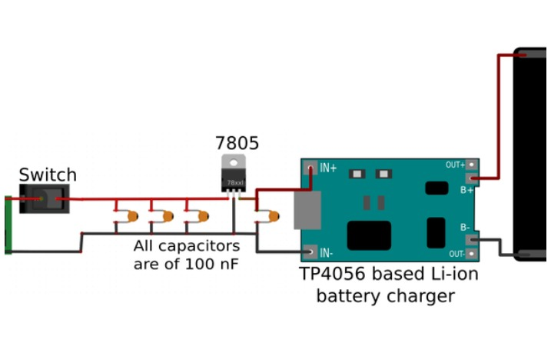

* Fig. 2:Water Level Sensor & Soil Moisture Detection Sensor Connections

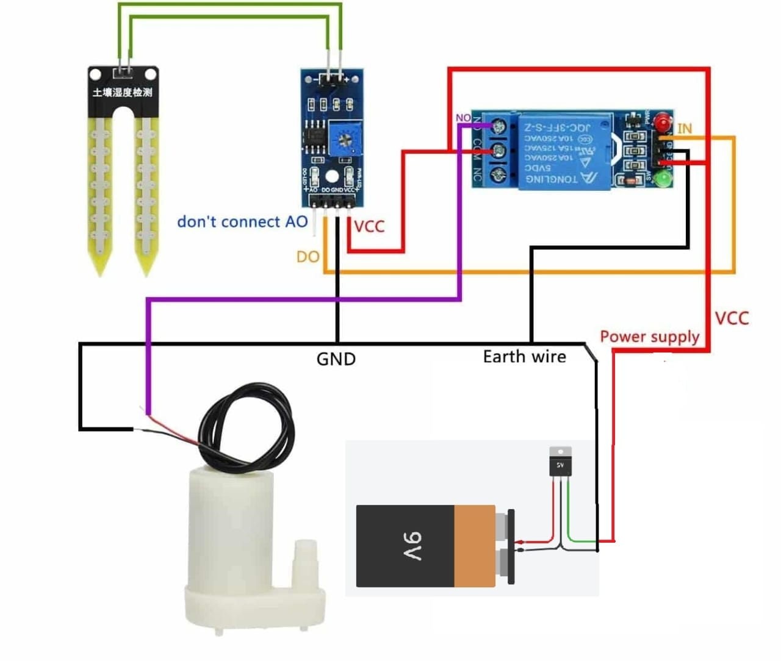

1. Water Level Sensor -

Investigate the design of a water level sensor device that is able to detect and control the level of water in a certain water tank or a similar water storage system.

<https://ieeexplore.ieee.org/abstract/document/7818550>  
By IEEE

1. Soil Moisture Sensor -

A wireless application of drip irrigation automation supported by soil moisture sensors.

<https://academicjournals.org/journal/SRE/article-full-text-pdf/4644D6C20216.pdf>  
By Academic Journals